1.

(a) Define Multitier architecture. [2]

(b) Outline the contribution that failover makes as one of the main advantages and improvements of EMIS. [2]

2.

(a) Suggest how the use of emergency reporting APP could lead to a safer and more efficient city environment under the circumstance of all citizens have smartphones with them. [4]

(b) One of the ethical problem issues identified in the case study as being a possible consequence for the new EMIS system is that user information and reported records may be hacked or lacked out for commercial use or criminal use.

By examining the above statements, discuss the level of importance that the technical team should avoid ethical problems. [4]

3. A fire station is built at point A, please use the Dijkstra’s algorithm for finding the shortest distance between two points and simulate the algorithm calculate the best route with the shortest distance for a fire engine to move from its station to point F?

The diagram below shows a partial map of the town’s roads where the numbers are the times taken to travel between adjacent nodes (where the nodes represent intersections of the roads. Without writing code, state the basic steps that are followed by this algorithm. [6]

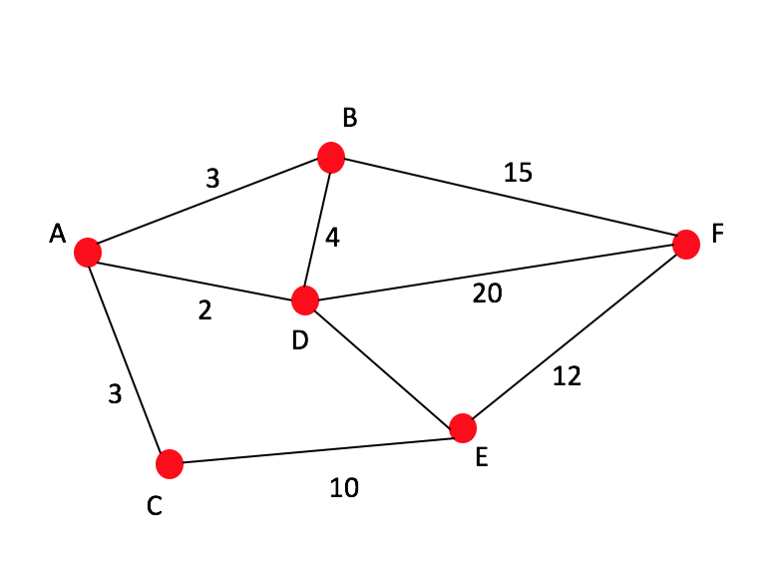

4.

One of the major contributions that makes it possible for citizens to use their smart phone APP to report emergency situations is the popularization of high-speed mobile networks.

Discuss the contribution that cellular networks have made to the anticipated success of the new EMIS system. You should make the reference to the computer science identified in this case study. [12]